Multi-Asset Commodity Risk Premia: Research Summary
Metals, Energy, Precious Metals, NGL, Agriculture, Correlation Analysis, and Cross-Commodity Portfolio
Basis of all results: daily returns net of 5 bp round-trip transaction costs, 1 January 2011 to 23 September 2026. Return is the annualised compound return, Vol the annualised volatility and IR their ratio (no risk-free rate). Equal Weight (EW PORT) averages the components equally; Inverse Vol weights each component by the inverse of its trailing 63-day volatility, lagged one day. Regimes: R1 2011-2016, R2 2017-2021, R3 2022-2026; 2026+ is the 2026 year to date. Energy includes Natural Gas unless stated.

Key Findings
- NGL is the strongest sleeve in the research: Equal Weight (IR +1.14) and Inverse Vol (IR +1.11) are more than double the best of any other asset class, and Momentum, Carry, and Carry-Momentum are each positive in every regime, as they are in Energy.
- Energy's Carry-Momentum is its strongest strategy (IR +0.58), and Value (IR -0.17) is the only Energy strategy with a negative full-sample IR; excluding Natural Gas improves every sleeve and lifts the Equal Weight portfolio from IR +0.49 to +0.59.
- In Metals, Value is the only strategy with a clear edge (IR +0.47); both portfolio constructions (Equal Weight -0.04, Inverse Vol +0.11) underperform simply holding Value alone, since blending in three strategies with little or no edge dilutes the one signal that works.
- Precious Metals and Agriculture are the two asset classes where portfolio construction fails: neither earns a positive IR (Precious Metals Equal Weight -0.21, Inverse Vol -0.21; Agriculture -0.21 and -0.24). Momentum is negative in both (Precious Metals -0.31, Agriculture -0.15), and in Agriculture all four strategies are net negative.
- Energy-NGL is the most correlated pair of asset classes for all six series types (EW PORT correlation 0.33) and Metals-Precious Metals the second most correlated under EW PORT (0.20), yet standalone Energy-NGL is the best-performing of the ten pairs (Equal Weight IR +0.99, Inverse Vol +1.01), proving correlation and performance are separate questions.
- The cross-commodity portfolio (each strategy equal-weighted across the five asset classes, then the four strategies combined) delivers Equal Weight IR +0.65 and Inverse Vol IR +0.72 at a volatility of 5.5%, is positive in every regime under both constructions, and is negatively correlated with equity (-0.19), a traditional 60/40 portfolio (-0.19) and even a passive commodity index (-0.07), genuine diversification, not repackaged beta.

Metals
- Momentum (Return -6.2%, Vol 15.5%, Max Drawdown -70.7%, IR -0.40): negative in two of three regimes (R1 -0.60, R3 -0.55) and roughly flat in R2 (+0.05); its only strongly positive window is the 2026 year to date (IR +1.05).
- Carry (Return +1.5%, Vol 12.2%, Max Drawdown -40.1%, IR +0.12) and Carry-Momentum (Return -1.0%, Vol 11.2%, Max Drawdown -58.7%, IR -0.09): both earn their positive results in R1 (IR +0.61 / +0.74) and turn negative in R2 (-0.39 / -0.69) and R3 (-0.04 / -0.52). The R1 result is concentrated in Aluminium (Carry IR +0.99) and Zinc (+0.57), the two metals whose curves were in the steepest contango in that period (average F1-F13 slope of -4.2% and -2.4%, backwardated on only 1% and 3% of days), the years of large LME stocks and aluminium financing deals; contango eased in both metals in R2 and R3 (Aluminium -2.6% and -2.3%, Zinc +1.2% and +1.2%).
- Value (Return +5.2%, Vol 11.1%, Max Drawdown -27.3%, IR +0.47): the strongest strategy and the only one with a clear edge, positive in every regime (R1 +0.59, R2 +0.08, R3 +0.76), though negative in the 2026 year to date (-0.90). It correlates at -0.49 with Momentum full-sample, the most negative pairing within the asset class and the strongest diversification relationship.
- Portfolio construction: Equal Weight (Return -0.2%, Vol 6.6%, Max Drawdown -25.9%, IR -0.04) and Inverse Vol (Return +0.7%, Vol 6.0%, Max Drawdown -19.0%, IR +0.11) both underperform holding Value alone (Return +5.2%, Vol 11.1%, Max Drawdown -27.3%, IR +0.47) on IR. Inverse Vol has the shallower drawdown and lower volatility of the two, but neither approaches Value's IR.
- Individual-metal decomposition: Momentum's blended IR of -0.40 masks a single working metal. Aluminium alone returns IR +0.22, the only positive result among the four, while Copper, Zinc, and Lead are all negative (Lead as low as -0.59). Value shows the opposite pattern, positive in every metal individually (+0.19 to +0.54), with blended volatility of 11.1% well below the roughly 16.5% average held by any one metal alone.
- Why neither construction beats Value: diversification only adds value when it combines more than one genuine edge. Value is the only strategy with a clear edge (IR +0.47); Carry is marginal (+0.12) and Momentum (-0.40) and Carry-Momentum (-0.09) are negative, so blending them with Value dilutes the one real signal in the book instead of diversifying real risk. The same logic applies within a strategy: blending Momentum across metals dilutes Aluminium's one working signal, while blending Value across metals, where every metal carries a positive edge, lifts the IR above the average single metal (+0.47 against +0.32).
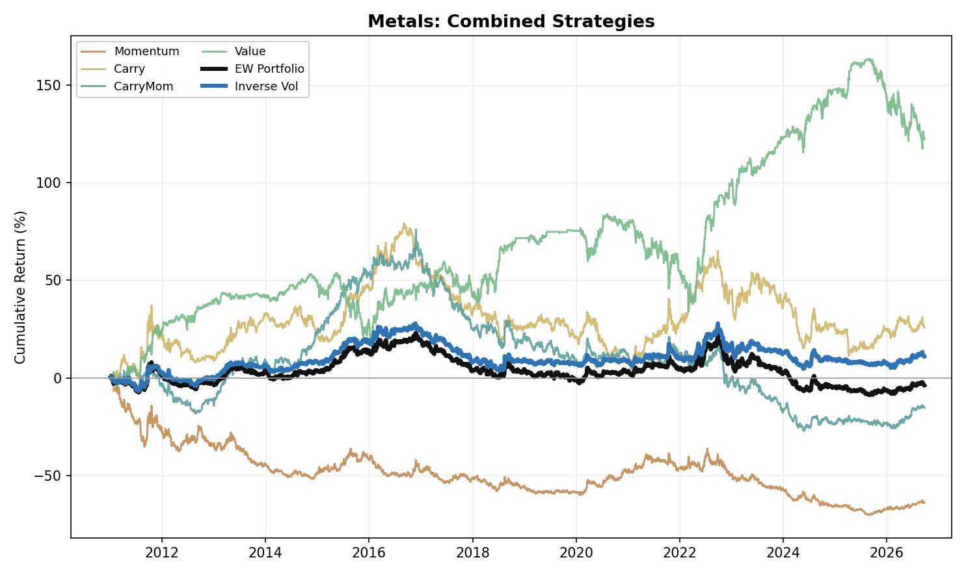
Figure 1. Metals: Combined Strategy Performance (Cumulative Return, 2011-2026)

Energy
- Carry-Momentum (Return +12.0%, Vol 20.8%, Max Drawdown -26.3%, IR +0.58) is the strongest individual strategy in the Energy basket and, like Momentum and Carry, is positive in every regime (Carry-Momentum R1 +0.54, R2 +0.53, R3 +0.71), the clearest evidence in Energy that term-structure changes carry genuine, repeatable information.
- Momentum (Return +13.2%, Vol 28.0%, Max Drawdown -55.4%, IR +0.47): positive in every regime (R1 +0.53, R2 +0.64, R3 +0.24), with most of its return earned in a few large directional moves: calendar years 2014, 2015, 2020 and 2021 account for 95% of its cumulative log return. They coincide with the 2014-2016 price collapse (WTI fell from $105 in June 2014 to $26 in February 2016, after OPEC's November 2014 decision to hold output against rising US shale supply), the 2020 demand collapse and the 2021 recovery. R3 is its weakest regime (the March 2022 spike to $124 after Russia's invasion of Ukraine added 14%) and the 2026 year to date its strongest (IR +2.19).
- Carry (Return +6.5%, Vol 25.0%, Max Drawdown -53.9%, IR +0.26) is positive in every regime (R1 +0.34, R2 +0.42, R3 +0.02) and weakest in R3 (IR +0.02), although the curves were the most backwardated of the sample (WTI F1-F3 backwardated on 87% of days in R3 against 21% in R1 and 46% in R2). The V2 signal is measured against each curve's own trailing 252-day slope, so a high level of backwardation does not by itself produce Carry returns.
- Value (Return -4.6%, Vol 26.6%, Max Drawdown -72.8%, IR -0.17) is the one consistent drag on a full-sample basis, negative in R1 (IR -0.46) and R3 (-0.13) and marginally positive in R2 (+0.09). The 2014-2016 price collapse (WTI from $105 to $26), triggered by US shale supply growth and OPEC's decision to hold output, behaves as a persistent trend rather than a mean-reverting cycle, exactly the environment a reversion strategy is built to lose in. It correlates at -0.49 with Momentum and -0.50 with Carry, the same diversification relationship seen in Metals (-0.49 with Momentum).
- Portfolio construction: Equal Weight (Return +6.5%, Vol 13.4%, Max Drawdown -27.8%, IR +0.49) and Inverse Vol (Return +6.4%, Vol 13.4%, Max Drawdown -27.5%, IR +0.48) are almost identical and both positive in every regime (Equal Weight R1 +0.35, R2 +0.82, R3 +0.31; Inverse Vol R1 +0.34, R2 +0.79, R3 +0.31). Unlike Metals, where Inverse Vol lifts the portfolio, the choice of weighting makes no material difference in Energy.
- Excluding Natural Gas (Energy ex-NatGas) improves every sleeve: Momentum +0.47 to +0.50, Carry +0.26 to +0.32, Carry-Momentum +0.58 to +0.64, Value -0.17 to -0.12 (IR). Equal Weight (Return +9.0%, Vol 15.4%, Max Drawdown -28.7%, IR +0.59) and Inverse Vol (Return +9.2%, Vol 15.2%, Max Drawdown -27.0%, IR +0.61) rise accordingly (from IR +0.49 and +0.48 with Natural Gas).
- Individual-product decomposition: Momentum and Carry-Momentum work across WTI, Brent, RBOB, and Heating Oil (IR +0.25 to +0.60) but carry no edge in Natural Gas (IR +0.04 and -0.03), consistent with gas's weather- and basis-driven price action decoupling from the broader term-structure logic. Value is negative in every one of the five products (IR -0.01 to -0.24), a broad, structural failure, not a concentration issue the way Momentum's weakness in Metals was.
- Physical storage bottlenecks, pipeline capacity limits, and producers' structural need to hedge downside force the market to pay a continuous insurance premium to whoever takes the other side of that risk, the same economic logic that shows up as Carry-Momentum's clean, all-regime positive record above.
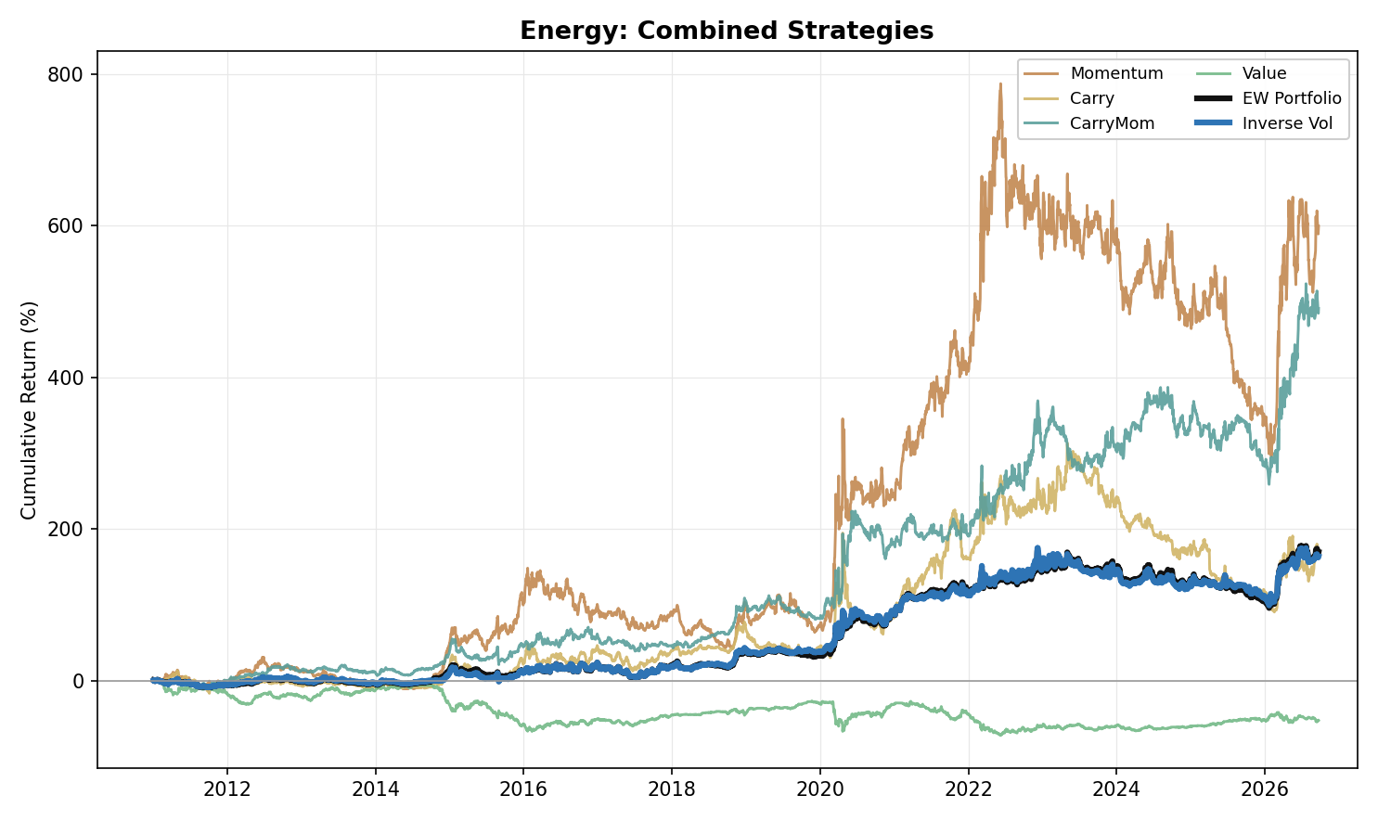
Figure 2. Energy: Combined Strategy Performance (Cumulative Return, 2011-2026)

Precious Metals
- Momentum (Return -6.5%, Vol 20.7%, Max Drawdown -77.8%, IR -0.31) is negative in every one of the three regimes (IR -0.25 to -0.46) and in the 2026 year to date (-0.30). Precious Metals are priced primarily off macro drivers, above all real yields (the weekly correlation of gold returns with changes in the 10-year real yield, FRED series DFII10, is -0.37 over the sample, -0.64 in R2 and -0.25 in R3), currency-debasement expectations and tail-risk demand, not off their own recent price action, so trend-following has nothing to extract.
- Carry (Return -1.1%, Vol 15.5%, Max Drawdown -55.4%, IR -0.07) and Carry-Momentum (Return +0.9%, Vol 14.3%, Max Drawdown -58.4%, IR +0.06) show no consistent edge: Carry is positive in R1 (IR +0.31), negative in R2 (-0.48) and flat in R3 (-0.02), while Carry-Momentum is positive in R1 (+0.57) and R2 (+0.28) before turning negative in R3 (-0.53), consistent with the post-2022 higher-real-yield environment pushing the sector deeper into cost-of-carry contango: the 10-year real yield averaged 1.61% in R3 against 0.03% in R2, and Gold's F1-F7 curve averaged -4.5% in R3 against -1.8% in R2 and -0.6% in R1 (Silver F1-F6 -4.5%, -2.3% and -0.9%).
- The long tenor pair does not change that conclusion. Carry IR: previous single pair (F1-F3) +0.00, short pair F1-F2 -0.09, long pair alone -0.04, two-pair blend -0.07. Carry-Momentum IR: previous single pair -0.14, short pair -0.03, long pair alone +0.13, two-pair blend +0.06.
- Value (Return -0.3%, Vol 18.6%, Max Drawdown -55.2%, IR -0.02) carries no full-sample edge, and the pattern is mixed at the product level: Platinum is the only metal with a real signal (IR +0.16), Silver (-0.03) and Palladium (+0.01) are flat, and Gold (-0.25) is negative.
- Portfolio construction: Equal Weight (Return -1.8%, Vol 8.6%, Max Drawdown -44.4%, IR -0.21) and Inverse Vol (Return -1.8%, Vol 8.4%, Max Drawdown -48.2%, IR -0.21) are both net negative full-sample. Precious Metals and Agriculture are the only two asset classes where neither construction earns a positive IR, and Carry-Momentum (IR +0.06) is the only Precious Metals strategy with a positive full-sample IR.
- Individual-metal decomposition: Momentum's failure is uniform across all four metals (Gold -0.01, Silver -0.11, Platinum -0.16, Palladium -0.46), none positive. Carry works in Gold (+0.22), Silver (+0.16) and Platinum (+0.16); its negative blended IR comes from Palladium (-0.48). Value's flat full-sample edge sits entirely in Platinum (IR +0.16); the other three metals show no edge or a negative one.
- Fundamentally, gold producers hedge little (the global producer hedge book was 218 tonnes in Q3 2017 and 182 tonnes at the end of 2024, World Gold Council), so there are few commercial hedgers paying an insurance premium to transfer downside risk to financial counterparties; without that premium, Momentum has no structural engine to harvest here.
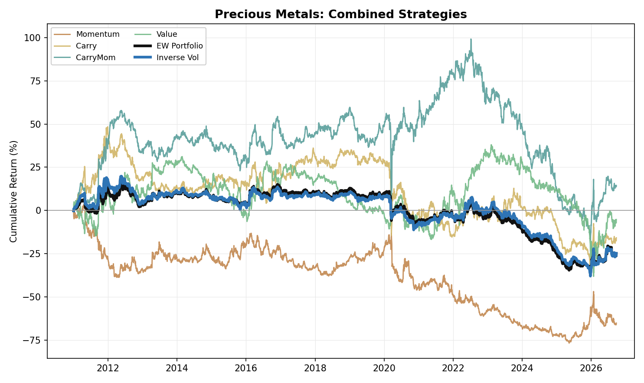
Figure 3. Precious Metals: Combined Strategy Performance (Cumulative Return, 2011-2026)

NGL
- NGL is the strongest sleeve in the research: Equal Weight (Return +15.4%, Vol 13.5%, Max Drawdown -19.0%, IR +1.14) and Inverse Vol (Return +14.9%, Vol 13.5%, Max Drawdown -21.7%, IR +1.11), the best full-sample IR of any asset class under both constructions. At the individual-strategy level, Momentum (IR +1.03), Carry (IR +0.92), and Carry-Momentum (IR +0.61) are positive in every one of the three regimes. Value (Return +1.7%, Vol 25.8%, Max Drawdown -71.9%, IR +0.07) is the exception: net positive full-sample but negative in R1 (-0.42), flat in R2 (+0.05) and strongly positive in R3 (+0.87).
- NGL's portfolios are strong in every regime rather than in one: Equal Weight IR is R1 +1.01, R2 +1.40, R3 +1.00 and Inverse Vol R1 +1.06, R2 +1.21, R3 +1.05, and the 2026 year to date reads +1.88 and +1.86. Both are well ahead of every other asset class, whose best full-sample Equal Weight IR is +0.49 (Energy). Value is the one sleeve whose picture changes, from -0.42 in R1 to +0.87 in R3 and +2.72 in the 2026 year to date.
- Two warm-up effects shape the early NGL figures. NGL price history starts in August to November 2009 and Value needs 630 observations of F3, so the Value sleeve contributes zero return for roughly the first 13 months of the reporting window and is invested in all four products only from 21 June 2012; with zero volatility in the window the Inverse Vol weights are undefined, so NGL Inverse Vol is defined only from 23 February 2012. The full-sample and R1 Inverse Vol statistics for NGL, and the books built on them, therefore cover 2012 onwards, while the Equal Weight series cover all of 2011.
- Carry (Return +20.0%, Vol 21.8%, Max Drawdown -41.1%, IR +0.92) is the clearest embodiment of NGL's seasonal mechanics: predictable weather- and industrial-driven demand cycles push futures curves from contango in low-demand build periods into steep backwardation as inventories drain in peak season. In the data the F2-F4 slope averages +3.8% (backwardation) in December to March and -1.5% (contango) in June to September. Carry is positive in every regime (IR +0.45 to +1.41), capturing that swing.
- The two portfolio constructions are close, with Equal Weight ahead on every measure: Equal Weight returns +15.4% against +14.9% for Inverse Vol at the same volatility (13.5%), with a shallower maximum drawdown (-19.0% against -21.7%) and a higher IR (+1.14 against +1.11).
- Individual-product decomposition: Momentum works uniformly across all four products (IR +0.60 to +0.98), the highest weakest-product result of any strategy in any asset class in the research. Carry (IR +0.40 to +0.85) and Carry-Momentum (IR +0.13 to +0.65) are also positive in every product. Value's modest full-sample edge is concentrated in Butane and Isobutane (IR +0.25 / +0.15), while Ethane and Propane show none (IR -0.13 / +0.00), the same split that explains Value's regime inconsistency above.
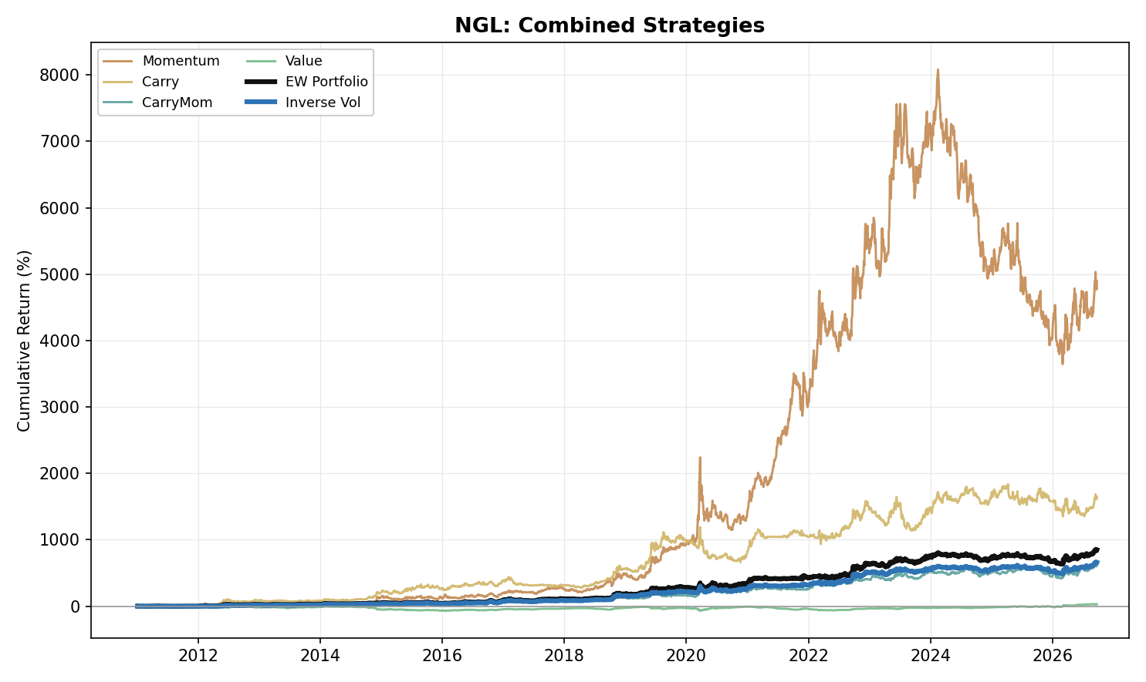
Figure 4. NGL: Combined Strategy Performance (Cumulative Return, 2011-2026)

Agriculture
- Agriculture (six products: Corn, Wheat, Soybean, Soybean Oil, Coffee, Sugar) has no edge in any sleeve: all four strategies are net negative full-sample, and Equal Weight (Return -1.4%, Vol 6.5%, Max Drawdown -31.7%, IR -0.21) and Inverse Vol (Return -1.5%, Vol 6.3%, Max Drawdown -29.0%, IR -0.24) follow. Together with Precious Metals it is one of the two asset classes where neither portfolio construction earns a positive IR.
- Momentum (Return -2.0%, Vol 13.2%, Max Drawdown -47.7%, IR -0.15) is negative in R1 (IR -0.23) and R3 (-0.31) and marginally positive in R2 (+0.11); the 2026 year to date is positive (+0.40).
- Carry (Return -1.3%, Vol 10.0%, Max Drawdown -33.3%, IR -0.13) and Carry-Momentum (Return -2.0%, Vol 10.0%, Max Drawdown -37.5%, IR -0.20) earn a positive IR only in R2 (Carry +0.48, Carry-Momentum +0.20); both are negative in R1 (-0.20 / -0.02) and at their worst in R3 (-0.67 / -0.78), and both are negative again in the 2026 year to date (-0.50 / -0.95).
- The long tenor pair matters little for the result. Carry IR: previous single pair (F1-F2) -0.30, long pair alone +0.08, two-pair blend -0.13. Carry-Momentum IR: previous single pair -0.08, long pair alone -0.26, two-pair blend -0.20.
- Value (Return -0.2%, Vol 13.5%, Max Drawdown -47.9%, IR -0.01) is flat full-sample: positive in R1 (IR +0.19), negative in R2 (-0.24) and R3 (-0.07), with a strong but partial-year 2026 reading (+2.12).
- Portfolio construction: both portfolios are positive only in R2 (Equal Weight +0.22, Inverse Vol +0.22) and negative in R1 (-0.10 / -0.24) and R3 (-0.76 / -0.67); the R3 losses drive the negative full-sample result.
- Individual-product decomposition: no sleeve works across the six products. Momentum is negative in Corn (-0.29), Wheat (-0.19) and Soybean (-0.19) and flat to slightly positive in Soybean Oil (+0.03), Coffee (+0.11) and Sugar (+0.02). The best single product-sleeve result is Wheat Value (IR +0.19) and the weakest is Wheat Carry-Momentum (-0.40); Corn Momentum (-0.29) and Corn Value (-0.27) are the next weakest.
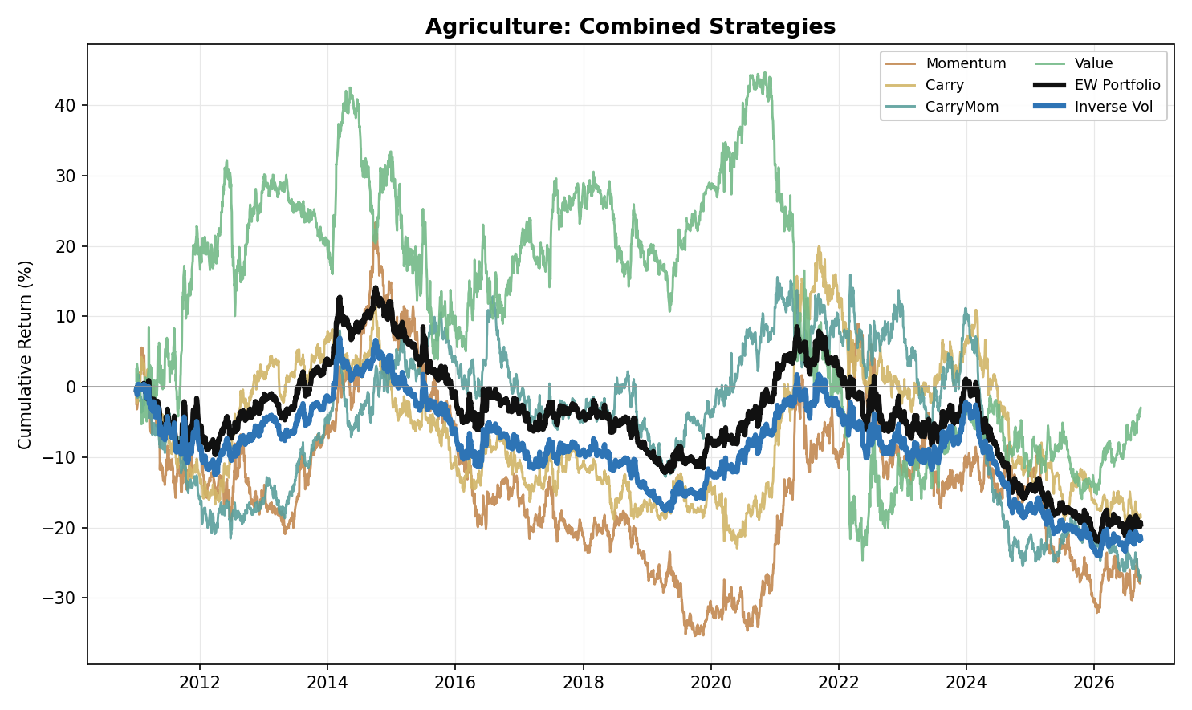
Figure 5. Agriculture: Combined Strategy Performance (Cumulative Return, 2011-2026)

Correlation Analysis

Within-Asset-Class Correlation
- Value is the least correlated sleeve with its own EW PORT in every asset class, correlating at only +0.02 in Metals, -0.10 in Energy and +0.04 in NGL. The diversification is weaker in Precious Metals (+0.12) and weakest in Agriculture (+0.31), where Value works against diversification more than anywhere else, though it is still the least correlated of the four sleeves there.
- Momentum and Carry are the most correlated pair of base strategies in Energy (0.66), NGL (0.66) and Agriculture (0.40), both moving with the same underlying trend signal. Metals and Precious Metals each break this pattern: in both, Carry and Carry-Momentum are the closest pair (0.39 in Metals, 0.56 in Precious Metals). Value is negatively correlated with Momentum in all five asset classes (-0.49 Metals, -0.49 Energy, -0.46 NGL, -0.39 Precious Metals, -0.23 Agriculture).
- Inverse Vol tracks its own Equal Weight portfolio closely everywhere, correlating between 0.95 and 0.99 across all five asset classes, expected since both portfolios are built from the same four sleeves and differ only in how they are weighted.

Cross-Commodity Correlation
- Energy and NGL are the most correlated cross-commodity pair for all six series types tracked: Momentum (0.46), Carry (0.20), Carry-Momentum (0.18), Value (0.54), EW PORT (0.33) and Inverse Vol (0.32), both trading the same underlying hydrocarbon complex.
- Metals-Precious Metals is the second most correlated pair for Momentum (0.24), Carry (0.10) and EW PORT (0.20), despite the two asset classes having different fundamental drivers. For Value (0.25) and Carry-Momentum (0.06) the second most correlated pair is Energy-Agriculture, and Metals-Precious Metals is essentially uncorrelated for Carry-Momentum (0.01).
- Carry-Momentum is the most genuinely diversifying strategy across commodities: its correlations to the same strategy in other asset classes average just 0.04 in magnitude, the lowest of the six series (Carry 0.06; the other four range 0.08 to 0.20), and none of its ten pairwise readings exceeds 0.18.

Portfolio Construction Implication
- The Cross-Pair tab shows all ten asset-class pairs. Under the EW PORT measure, Energy-NGL (0.33) and Metals-Precious Metals (0.20) are the two most correlated pairs; every other pair is at or below 0.10. The table below sets each pair's EW PORT correlation beside its full-sample IR under Equal Weight and Inverse Vol (Energy including Natural Gas).
Pair | EW PORT correlation | Equal Weight IR | Inverse Vol IR
Energy-NGL | 0.33 | +0.99 | +1.01
Metals-NGL | 0.07 | +0.95 | +0.94
NGL-Agriculture | 0.05 | +0.88 | +0.71
Precious Metals-NGL | 0.03 | +0.80 | +0.47
Metals-Energy | 0.08 | +0.41 | +0.44
Energy-Agriculture | 0.10 | +0.33 | +0.24
Energy-Precious Metals | 0.04 | +0.28 | +0.23
Metals-Agriculture | 0.09 | -0.17 | -0.11
Metals-Precious Metals | 0.20 | -0.18 | -0.03
Precious Metals-Agriculture | 0.10 | -0.28 | -0.30
- Correlation and standalone performance are separate questions. Held on its own, Energy-NGL, the most correlated pair, produces the highest full-sample IR of the ten pairs under both constructions (Equal Weight +0.99, Inverse Vol +1.01), while Precious Metals-Agriculture produces the lowest (-0.28 and -0.30). Two individually strong books can still make a poor diversification pairing simply because they move together.

Cross-Commodity Portfolio
- Diversifying each individual strategy across all five asset classes first (equal-weighted), then combining strategies, lifts every strategy above its worst individual asset-class showing: Momentum (Return +4.6%, Vol 12.5%, Max Drawdown -36.0%, IR +0.37), Carry (Return +4.9%, Vol 8.7%, Max Drawdown -26.4%, IR +0.57), Carry-Momentum (Return +4.5%, Vol 7.9%, Max Drawdown -24.7%, IR +0.57), Value (Return +0.3%, Vol 12.1%, Max Drawdown -44.6%, IR +0.03). The worst asset-class IRs for the same strategies are -0.40, -0.13, -0.20 and -0.17.
- At the top level, combining those four cross-commodity strategies gives Equal Weight (Return +3.6%, Vol 5.5%, Max Drawdown -18.8%, IR +0.65) and Inverse Vol (Return +4.0%, Vol 5.5%, Max Drawdown -17.2%, IR +0.72). Inverse Vol is the stronger construction, with the higher return and IR and the shallower drawdown at the same volatility.
- The cross-commodity book is positive in every one of the three regimes under both constructions (Equal Weight R1 +0.80, R2 +1.03, R3 +0.17; Inverse Vol R1 +1.00, R2 +0.89, R3 +0.32). Among the single asset classes only Energy and NGL do the same, and both do so at more than twice the cross-commodity volatility (Equal Weight 13.4% and 13.5% against 5.5%).
- The weakest regime for the cross-commodity book is R3 (Equal Weight IR +0.17, Inverse Vol +0.32), still positive but a fraction of the strength shown in R1 and R2. The partial 2026 window is exceptionally strong across both constructions (IR +2.25 and +2.36), led by Carry-Momentum's cross-commodity IR of +2.54 that year.
- Excluding Natural Gas from Energy lifts the book to Equal Weight (Return +4.1%, Vol 5.8%, Max Drawdown -18.6%, IR +0.70) and Inverse Vol (Return +4.5%, Vol 5.8%, Max Drawdown -17.2%, IR +0.78). Combining in the opposite order, each asset class's four sleeves first and then the five asset-class portfolios, gives the identical Equal Weight result (IR +0.65); the three other weighting combinations give IRs of +0.54, +0.70 and +0.52 (sleeves Equal Weight / across Inverse Vol; sleeves Inverse Vol / across Equal Weight; Inverse Vol at both stages).
- Across all ten asset-class pairings, Energy-NGL is the best-performing combination under both constructions (Equal Weight +0.99, Inverse Vol +1.01) even though it is the most correlated pair. The only pairs with a negative full-sample IR under either construction are the three built from Metals, Precious Metals and Agriculture alone: Metals-Precious Metals (-0.18 / -0.03), Metals-Agriculture (-0.17 / -0.11) and Precious Metals-Agriculture (-0.28 / -0.30), and each is negative in both R2 and R3 under Equal Weight, consistent with those three asset classes' own EW PORT IRs of -0.04, -0.21 and -0.21. Metals-NGL is the most construction-robust pair (Equal Weight +0.95, Inverse Vol +0.94), while Inverse Vol's effect is otherwise uneven: it pulls down Precious Metals-NGL most (+0.80 to +0.47), consistent with inverse-vol weighting dialing down NGL's higher-volatility portfolio (13.5% against 8.6% for Precious Metals). Replacing Energy with Energy ex-NatGas lifts all four Energy pairs under Equal Weight.
- Benchmarked against traditional assets, the cross-commodity book is a genuine diversifier rather than repackaged commodity beta: both constructions correlate negatively with Equity (Equal Weight -0.19, Inverse Vol -0.20) and with a traditional 60/40 portfolio (-0.19, -0.20), stay close to zero against Fixed Income (-0.03, -0.03), and are also negatively correlated with a passive Commodity Index (-0.07, -0.07), confirming these are genuinely active long/short signals, not disguised long-only commodity exposure. Value is the one exception, the only strategy positively correlated with Equity and the 60/40 portfolio (+0.09, +0.09); among the base strategies, Value is the most negatively correlated with Gold (-0.15), while Momentum, Carry and Carry-Momentum are essentially uncorrelated with it (+0.01, -0.01, -0.01). The correlations use daily returns of the SPY, AGG, DBC and GLD ETFs on the days they share with the strategy series, from 2011 to 23 September 2026. Full detail in the Appendix.
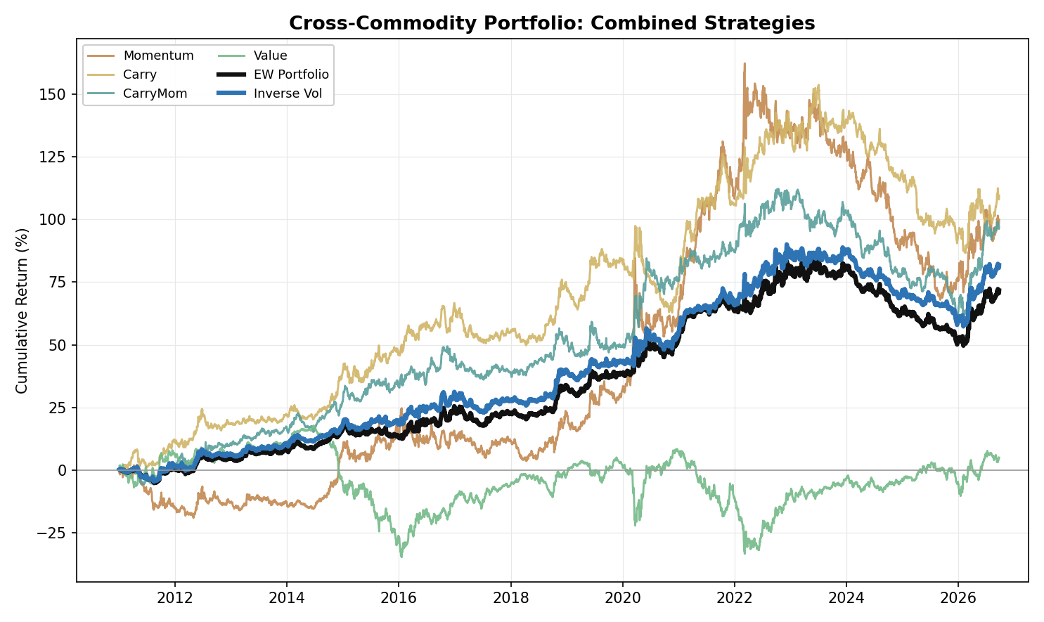
Figure 6. Cross-Commodity Portfolio: Combined Strategy Performance (Cumulative Return, 2011-2026)

Appendix: Regime-Level Detail
Table A1. Metals: Strategy Information Ratios by Regime
 | Full | 2011-16 | 2017-21 | 2022-26 | 2026+
Momentum | -0.40 | -0.60 | +0.05 | -0.55 | +1.05
Carry | +0.12 | +0.61 | -0.39 | -0.04 | +0.11
Carry-Momentum | -0.09 | +0.74 | -0.69 | -0.52 | +1.56
Value | +0.47 | +0.59 | +0.08 | +0.76 | -0.90

Table A2. Metals: Portfolio Construction Information Ratios by Regime
 | Full | 2011-16 | 2017-21 | 2022-26 | 2026+
Equal Weight | -0.04 | +0.42 | -0.44 | -0.26 | +0.80
Inverse Vol | +0.11 | +0.61 | -0.44 | +0.03 | +0.79

Table A3. Metals: Individual-Metal Information Ratios, All Strategies (Full Sample)
 | Copper | Aluminium | Lead | Zinc
Momentum | -0.40 | +0.22 | -0.59 | -0.27
Carry | +0.18 | +0.36 | -0.20 | +0.02
Carry-Momentum | +0.18 | -0.02 | -0.12 | -0.21
Value | +0.22 | +0.19 | +0.54 | +0.34

Table A4. Energy: Strategy Information Ratios by Regime
 | Full | 2011-16 | 2017-21 | 2022-26 | 2026+
Momentum | +0.47 | +0.53 | +0.64 | +0.24 | +2.19
Carry | +0.26 | +0.34 | +0.42 | +0.02 | +0.89
Carry-Momentum | +0.58 | +0.54 | +0.53 | +0.71 | +2.48
Value | -0.17 | -0.46 | +0.09 | -0.13 | -0.00

Table A5. Energy: Portfolio Construction Information Ratios by Regime
 | Full | 2011-16 | 2017-21 | 2022-26 | 2026+
Equal Weight | +0.49 | +0.35 | +0.82 | +0.31 | +2.22
Inverse Vol | +0.48 | +0.34 | +0.79 | +0.31 | +1.92

Table A6. Energy: Individual-Product Information Ratios, All Strategies (Full Sample)
 | WTI | Brent | RBOB | HeatingOil | NatGas
Momentum | +0.45 | +0.42 | +0.25 | +0.60 | +0.04
Carry | +0.12 | +0.24 | +0.08 | +0.71 | -0.09
Carry-Momentum | +0.46 | +0.56 | +0.43 | +0.40 | -0.03
Value | -0.05 | -0.01 | -0.14 | -0.24 | -0.19

Table A7. Energy ex-NatGas: Strategy and Portfolio Information Ratios by Regime
 | Full | 2011-16 | 2017-21 | 2022-26 | 2026+
Momentum | +0.50 | +0.46 | +0.66 | +0.37 | +2.61
Carry | +0.32 | +0.32 | +0.52 | +0.10 | +1.55
Carry-Momentum | +0.64 | +0.57 | +0.73 | +0.64 | +2.77
Value | -0.12 | -0.36 | +0.07 | -0.03 | -0.02
Equal Weight | +0.59 | +0.38 | +0.96 | +0.43 | +2.89
Inverse Vol | +0.61 | +0.36 | +0.97 | +0.47 | +2.73

Table A8. Precious Metals: Strategy Information Ratios by Regime
 | Full | 2011-16 | 2017-21 | 2022-26 | 2026+
Momentum | -0.31 | -0.25 | -0.46 | -0.29 | -0.30
Carry | -0.07 | +0.31 | -0.48 | -0.02 | +0.74
Carry-Momentum | +0.06 | +0.57 | +0.28 | -0.53 | +1.25
Value | -0.02 | +0.13 | -0.07 | -0.13 | +0.48

Table A9. Precious Metals: Portfolio Construction Information Ratios by Regime
 | Full | 2011-16 | 2017-21 | 2022-26 | 2026+
Equal Weight | -0.21 | +0.26 | -0.49 | -0.48 | +0.82
Inverse Vol | -0.21 | +0.23 | -0.48 | -0.47 | +0.97

Table A10. Precious Metals: Individual-Metal Information Ratios, All Strategies (Full Sample)
 | Gold | Silver | Platinum | Palladium
Momentum | -0.01 | -0.11 | -0.16 | -0.46
Carry | +0.22 | +0.16 | +0.16 | -0.48
Carry-Momentum | +0.08 | +0.24 | +0.19 | -0.27
Value | -0.25 | -0.03 | +0.16 | +0.01

Table A11. Precious Metals: Carry Tenor Pairs, Full-Sample Information Ratios
 | Previous single pair (F1-F3) | Short pair (F1-F2) | Long pair alone | Two-pair blend
Carry | +0.00 | -0.09 | -0.04 | -0.07
Carry-Momentum | -0.14 | -0.03 | +0.13 | +0.06

Table A12. NGL: Strategy Information Ratios by Regime
 | Full | 2011-16 | 2017-21 | 2022-26 | 2026+
Momentum | +1.03 | +0.81 | +1.87 | +0.41 | +0.89
Carry | +0.92 | +1.41 | +0.81 | +0.45 | +0.23
Carry-Momentum | +0.61 | +0.51 | +0.59 | +0.80 | +1.61
Value | +0.07 | -0.42 | +0.05 | +0.87 | +2.72

Table A13. NGL: Portfolio Construction Information Ratios by Regime
 | Full | 2011-16 | 2017-21 | 2022-26 | 2026+
Equal Weight | +1.14 | +1.01 | +1.40 | +1.00 | +1.88
Inverse Vol | +1.11 | +1.06 | +1.21 | +1.05 | +1.86

Table A14. NGL: Individual-Product Information Ratios, All Strategies (Full Sample)
 | Ethane | Propane | Butane | Isobutane
Momentum | +0.80 | +0.60 | +0.98 | +0.67
Carry | +0.40 | +0.85 | +0.65 | +0.71
Carry-Momentum | +0.13 | +0.48 | +0.65 | +0.53
Value | -0.13 | +0.00 | +0.25 | +0.15

Table A15. Agriculture: Strategy Information Ratios by Regime
 | Full | 2011-16 | 2017-21 | 2022-26 | 2026+
Momentum | -0.15 | -0.23 | +0.11 | -0.31 | +0.40
Carry | -0.13 | -0.20 | +0.48 | -0.67 | -0.50
Carry-Momentum | -0.20 | -0.02 | +0.20 | -0.78 | -0.95
Value | -0.01 | +0.19 | -0.24 | -0.07 | +2.12

Table A16. Agriculture: Portfolio Construction Information Ratios by Regime
 | Full | 2011-16 | 2017-21 | 2022-26 | 2026+
Equal Weight | -0.21 | -0.10 | +0.22 | -0.76 | +0.34
Inverse Vol | -0.24 | -0.24 | +0.22 | -0.67 | +0.41

Table A17. Agriculture: Individual-Product Information Ratios, All Strategies (Full Sample)
 | Corn | Wheat | Soybean | SoybeanOil | Coffee | Sugar
Momentum | -0.29 | -0.19 | -0.19 | +0.03 | +0.11 | +0.02
Carry | -0.15 | -0.16 | +0.06 | -0.03 | -0.01 | -0.04
Carry-Momentum | -0.10 | -0.40 | -0.02 | +0.00 | +0.01 | +0.03
Value | -0.27 | +0.19 | -0.01 | -0.03 | +0.02 | +0.02

Table A18. Agriculture: Carry Tenor Pairs, Full-Sample Information Ratios
 | Previous single pair (F1-F2) | Long pair alone | Two-pair blend
Carry | -0.30 | +0.08 | -0.13
Carry-Momentum | -0.08 | -0.26 | -0.20

Table A19. Cross-Commodity Portfolio: Correlation vs Traditional Assets (2011 to 23 September 2026)
 | Equity | Fixed Income | Commodity Index | Gold | 60/40 Portfolio
Momentum | -0.22 | -0.03 | -0.09 | +0.01 | -0.22
Carry | -0.17 | -0.04 | +0.01 | -0.01 | -0.17
Carry-Momentum | -0.14 | -0.03 | -0.08 | -0.01 | -0.14
Value | +0.09 | +0.03 | -0.00 | -0.15 | +0.09
EW Portfolio | -0.19 | -0.03 | -0.07 | -0.09 | -0.19
Inverse Vol | -0.20 | -0.03 | -0.07 | -0.07 | -0.20

Table A20. Cross-Commodity Portfolio: Strategy Information Ratios by Regime (all 5 asset classes)
 | Full | 2011-16 | 2017-21 | 2022-26 | 2026+
Momentum | +0.37 | +0.21 | +0.96 | -0.07 | +1.18
Carry | +0.57 | +1.23 | +0.49 | +0.04 | +0.86
Carry-Momentum | +0.57 | +1.02 | +0.59 | +0.14 | +2.54
Value | +0.03 | -0.18 | +0.01 | +0.30 | +1.28

Table A21. Cross-Commodity Portfolio: Construction Information Ratios by Regime (all 5 asset classes)
 | Full | 2011-16 | 2017-21 | 2022-26 | 2026+
Equal Weight | +0.65 | +0.80 | +1.03 | +0.17 | +2.25
Inverse Vol | +0.72 | +1.00 | +0.89 | +0.32 | +2.36
Equal Weight (ex-NatGas) | +0.70 | +0.81 | +1.11 | +0.24 | +2.48
Inverse Vol (ex-NatGas) | +0.78 | +0.99 | +0.99 | +0.38 | +2.58

Table A22. Cross-Pair Portfolio: Full-Sample Information Ratios, All Ten Asset-Class Pairs
 | Equal Weight | Inverse Vol
Metals-Energy | +0.41 | +0.44
Metals-Precious Metals | -0.18 | -0.03
Metals-NGL | +0.95 | +0.94
Metals-Agriculture | -0.17 | -0.11
Energy-Precious Metals | +0.28 | +0.23
Energy-NGL | +0.99 | +1.01
Energy-Agriculture | +0.33 | +0.24
Precious Metals-NGL | +0.80 | +0.47
Precious Metals-Agriculture | -0.28 | -0.30
NGL-Agriculture | +0.88 | +0.71

Table A23. Cross-Pair Portfolio: Energy Pairs Excluding Natural Gas, Full-Sample Information Ratios
 | Equal Weight | Inverse Vol
Metals-Energy (ex-NatGas) | +0.50 | +0.49
Energy (ex-NatGas)-Precious Metals | +0.39 | +0.37
Energy (ex-NatGas)-NGL | +1.04 | +1.11
Energy (ex-NatGas)-Agriculture | +0.43 | +0.32

Appendix: Equity-Curve Charts
Individual equity curves underlying the combined-strategy figures above, decomposed by instrument for each strategy within each asset class, and by asset-class pair, one chart per construction method, for the Cross-Pair Portfolios (Energy including Natural Gas).

Metals
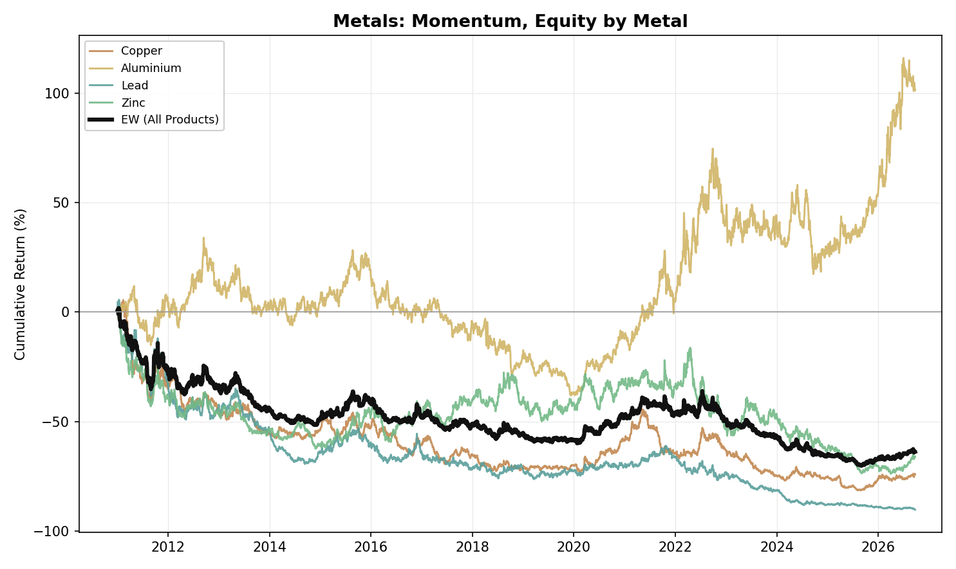
Figure A1. Metals, Momentum: Equity Curve by Metal (2011-2026)
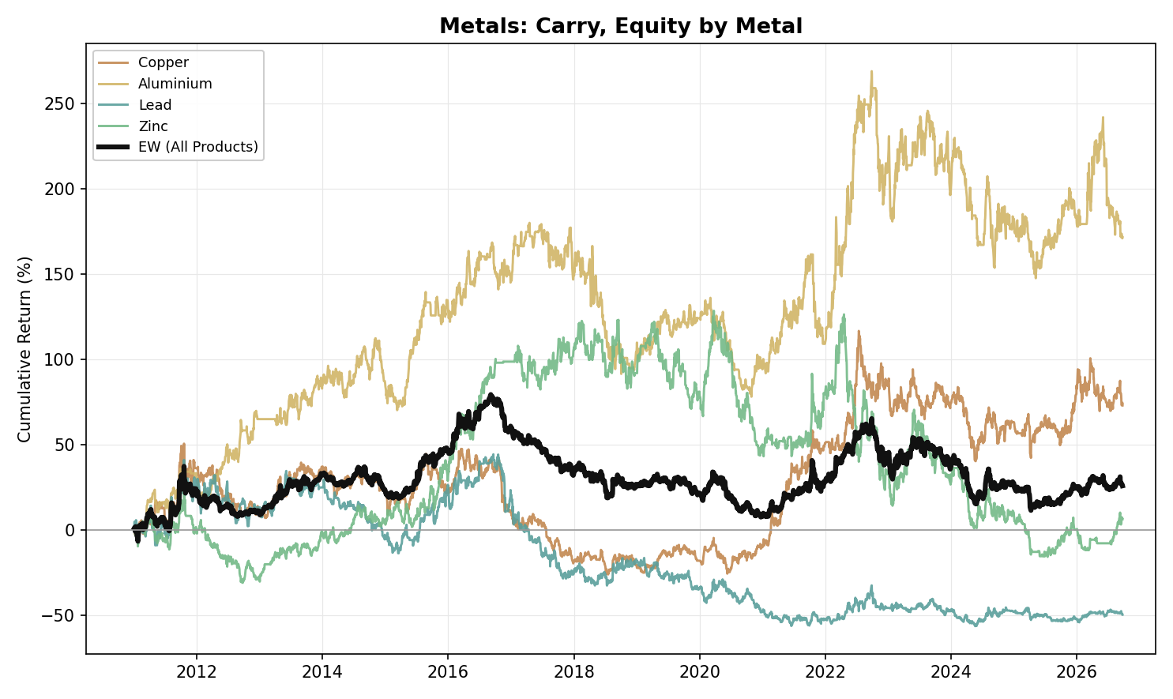
Figure A2. Metals, Carry: Equity Curve by Metal (2011-2026)
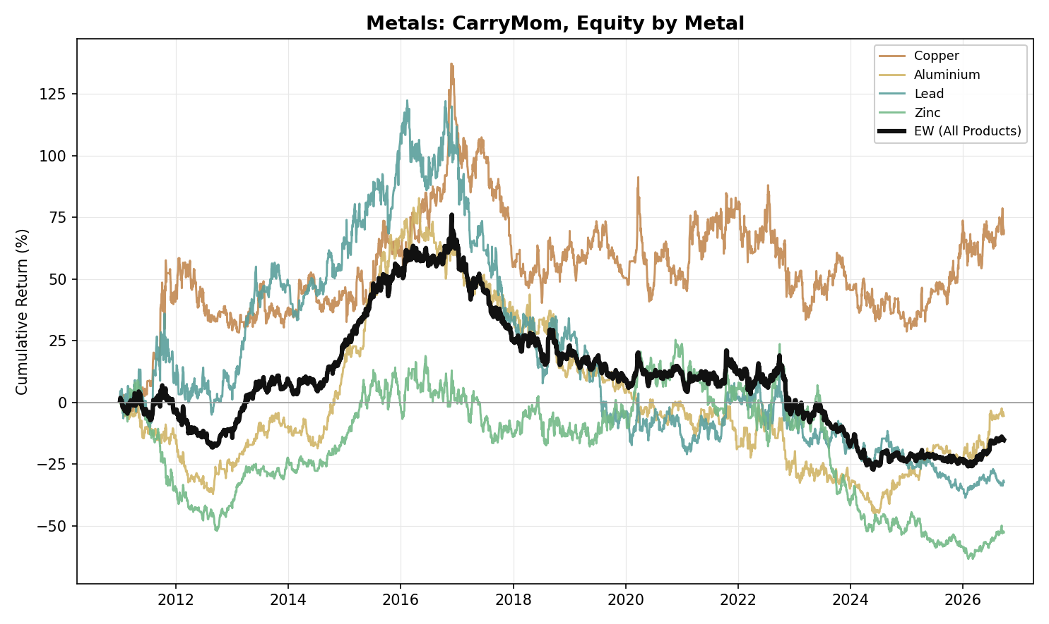
Figure A3. Metals, Carry-Momentum: Equity Curve by Metal (2011-2026)
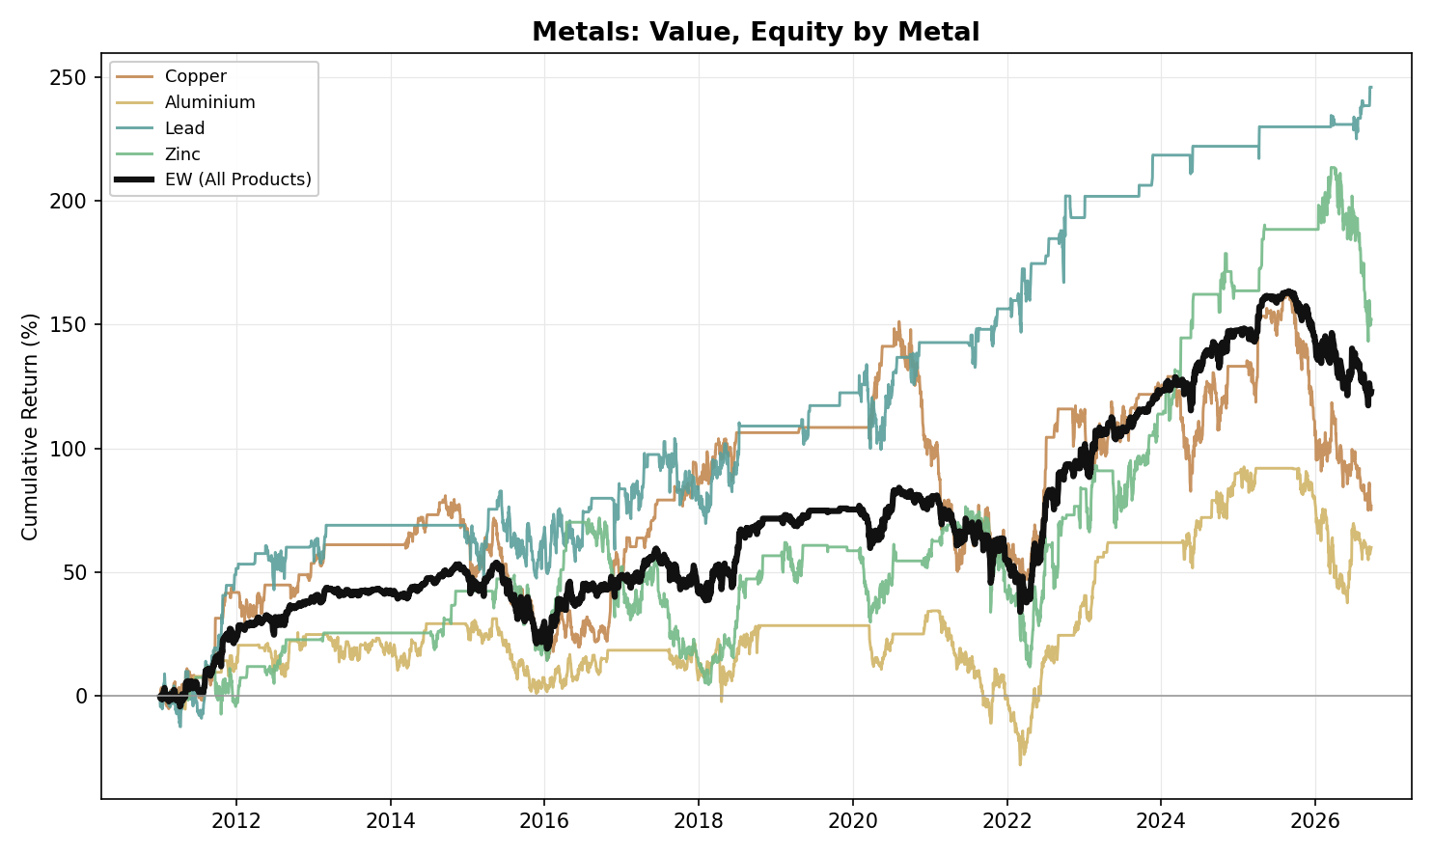
Figure A4. Metals, Value: Equity Curve by Metal (2011-2026)

Energy
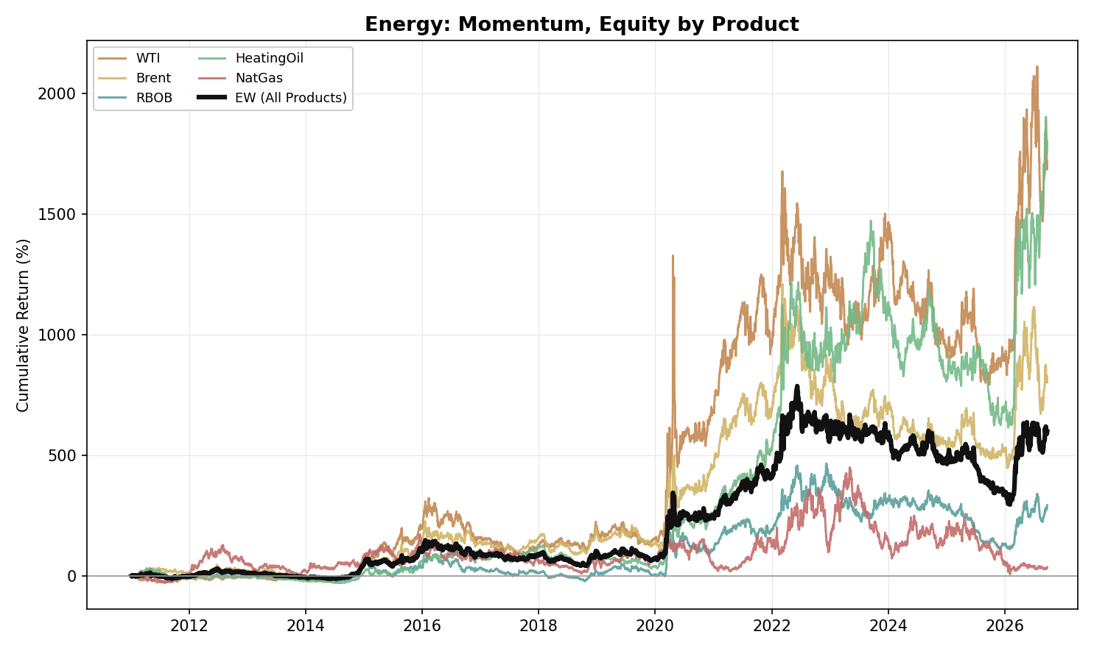
Figure A5. Energy, Momentum: Equity Curve by Product (2011-2026)
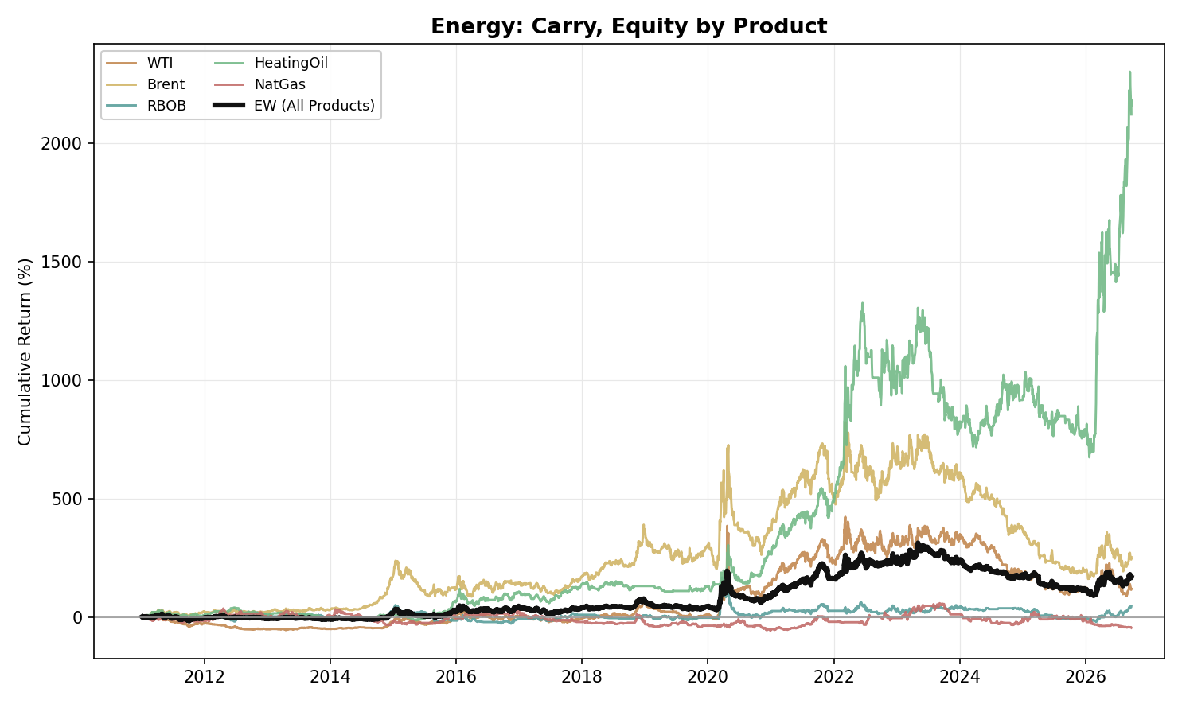
Figure A6. Energy, Carry: Equity Curve by Product (2011-2026)
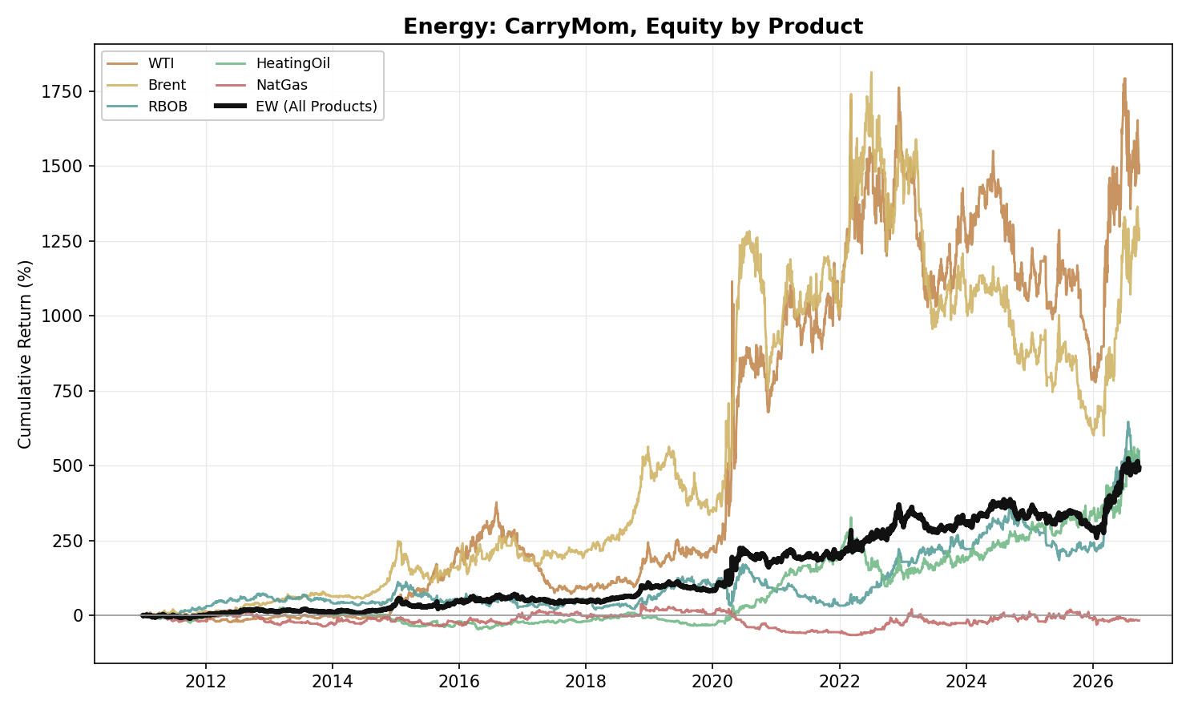
Figure A7. Energy, Carry-Momentum: Equity Curve by Product (2011-2026)
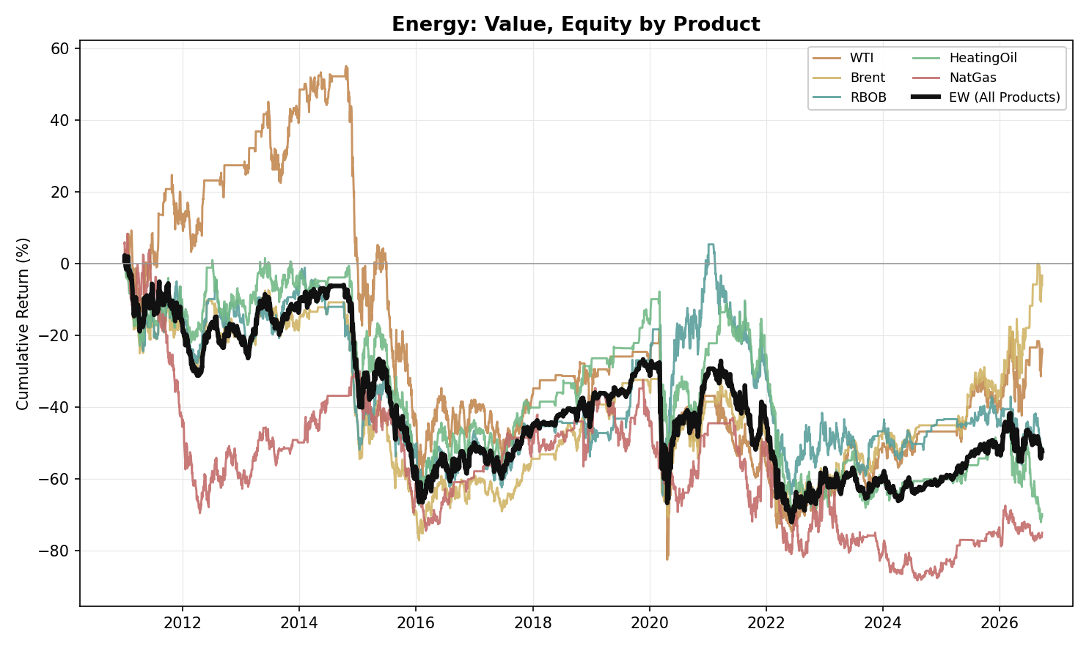
Figure A8. Energy, Value: Equity Curve by Product (2011-2026)

Precious Metals
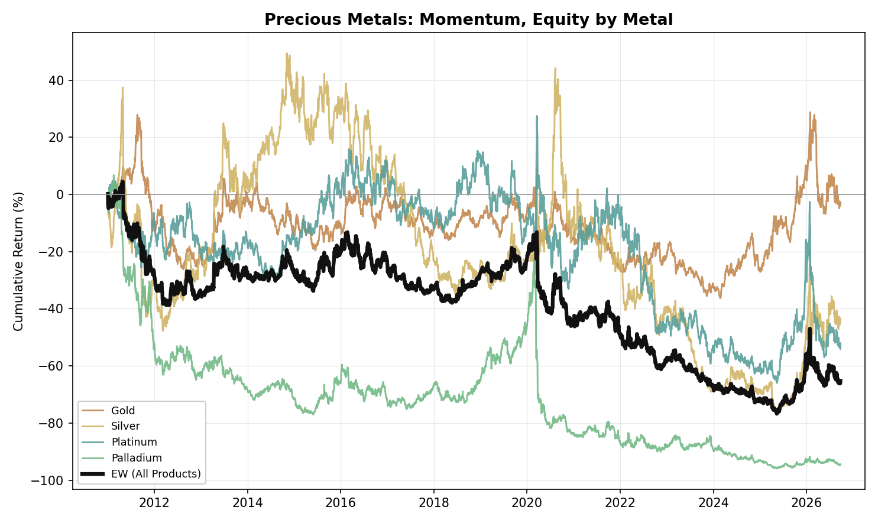
Figure A9. Precious Metals, Momentum: Equity Curve by Metal (2011-2026)
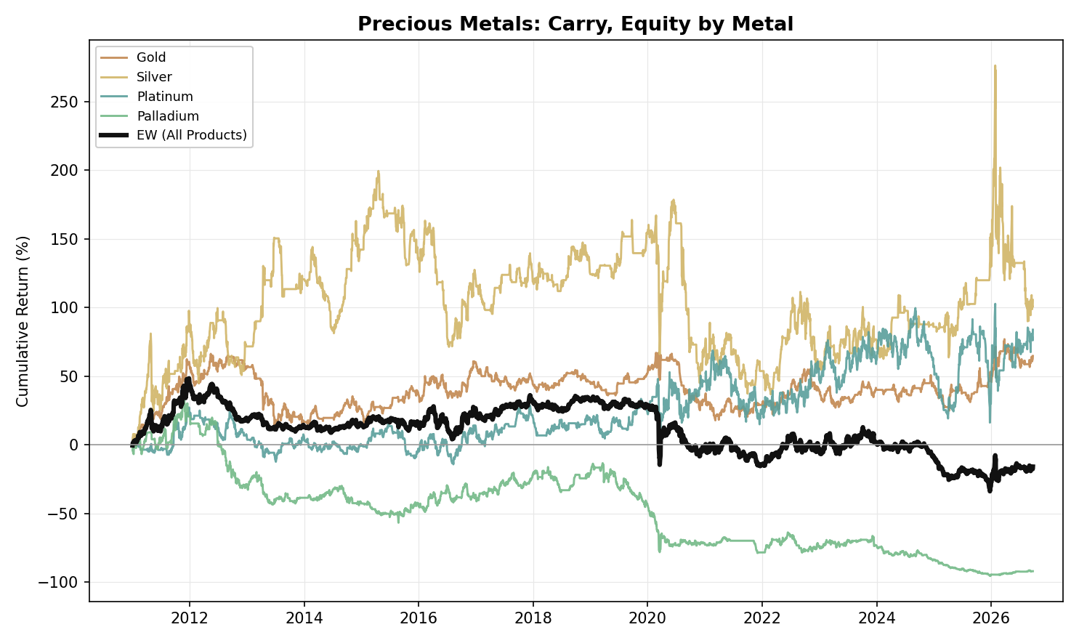
Figure A10. Precious Metals, Carry: Equity Curve by Metal (2011-2026)
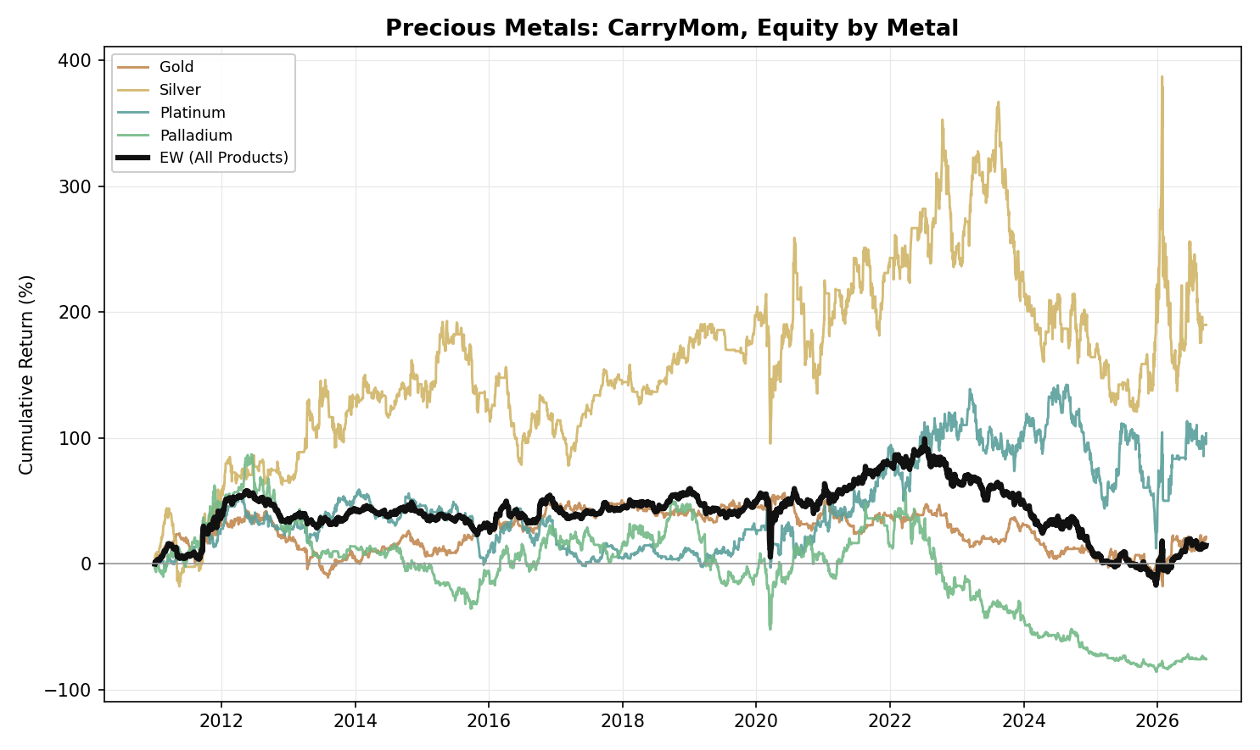
Figure A11. Precious Metals, Carry-Momentum: Equity Curve by Metal (2011-2026)
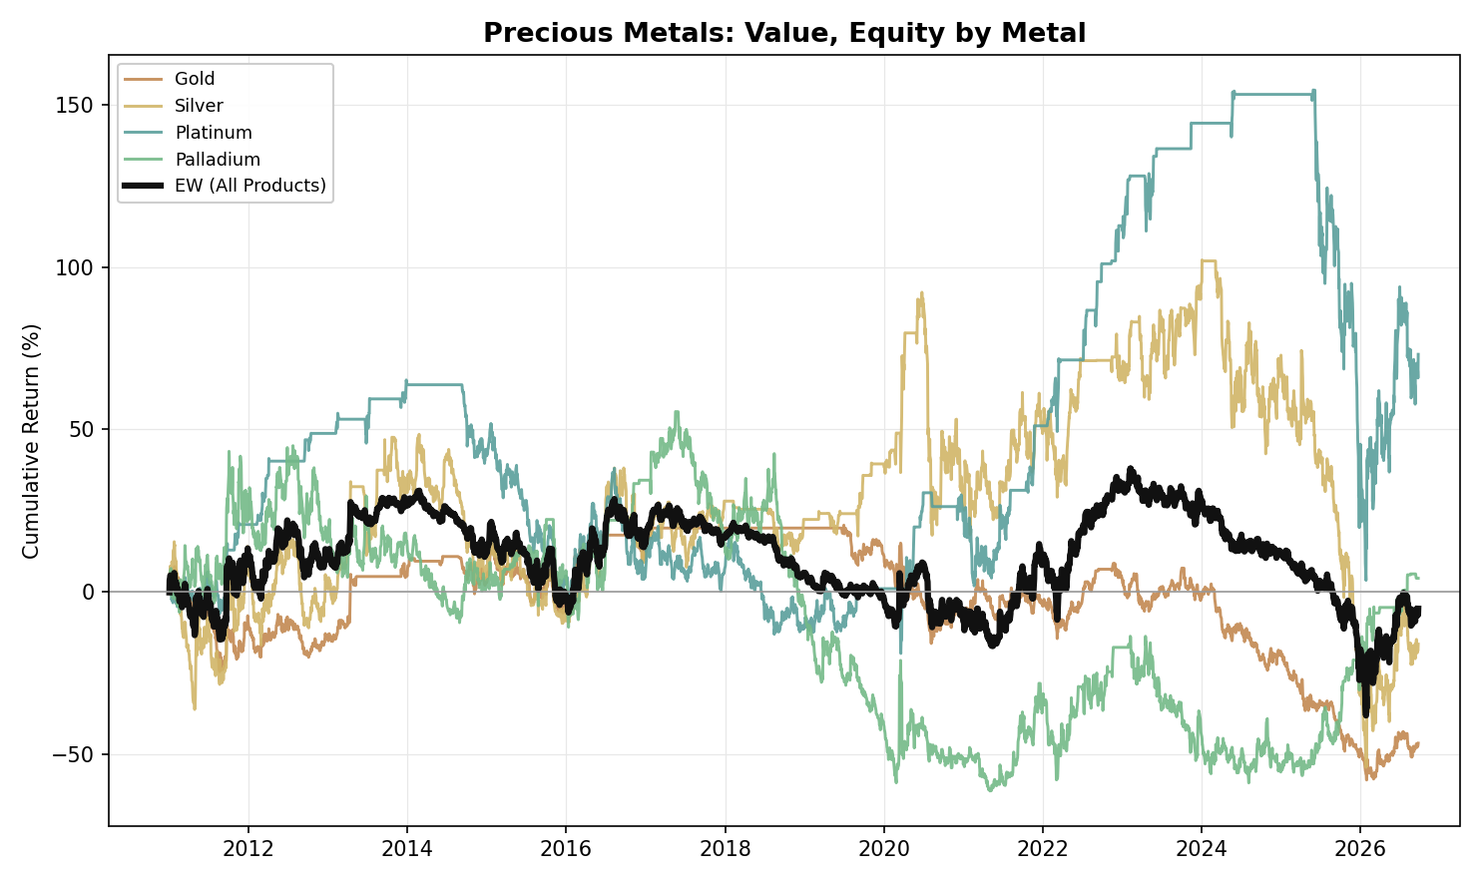
Figure A12. Precious Metals, Value: Equity Curve by Metal (2011-2026)

NGL
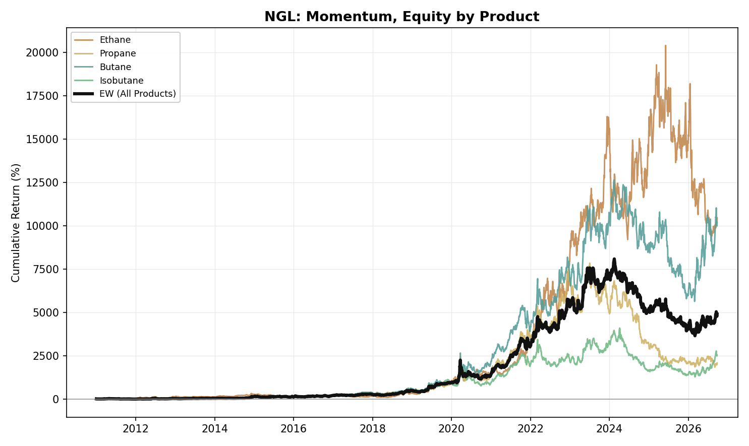
Figure A13. NGL, Momentum: Equity Curve by Product (2011-2026)
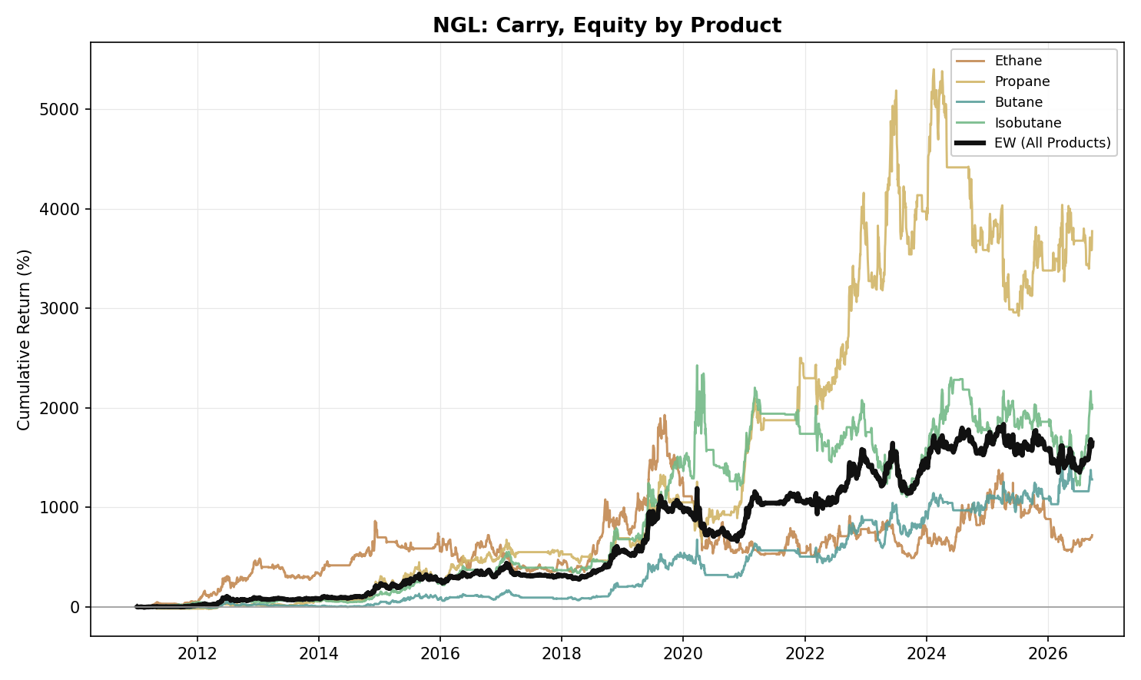
Figure A14. NGL, Carry: Equity Curve by Product (2011-2026)
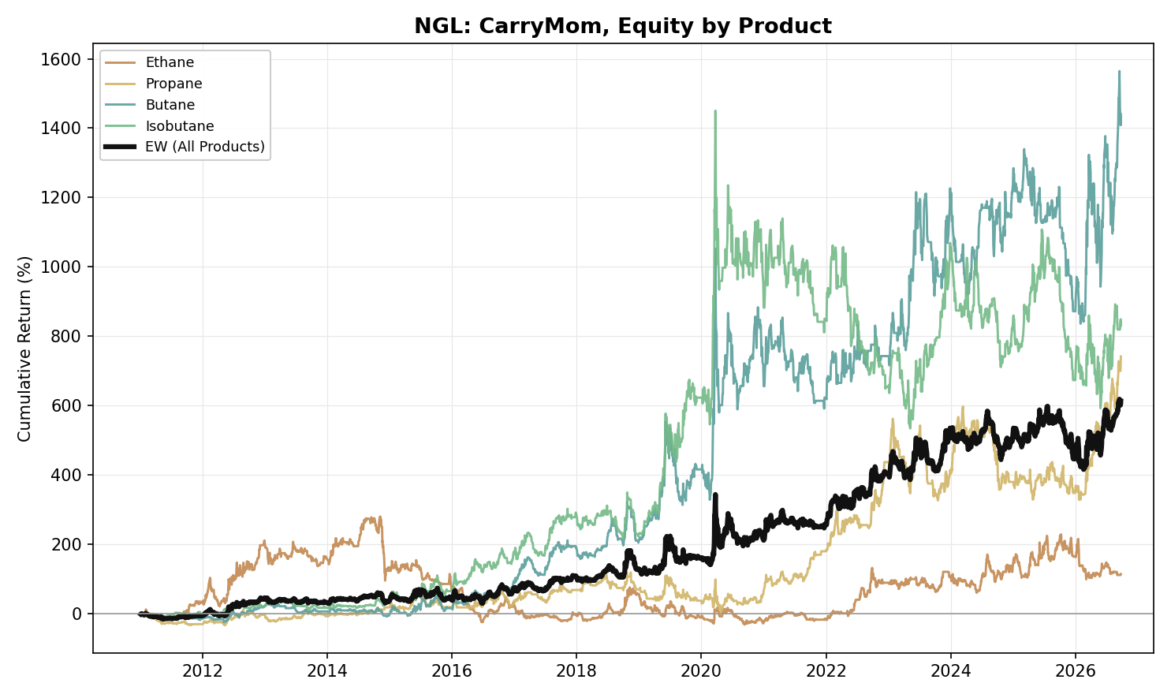
Figure A15. NGL, Carry-Momentum: Equity Curve by Product (2011-2026)
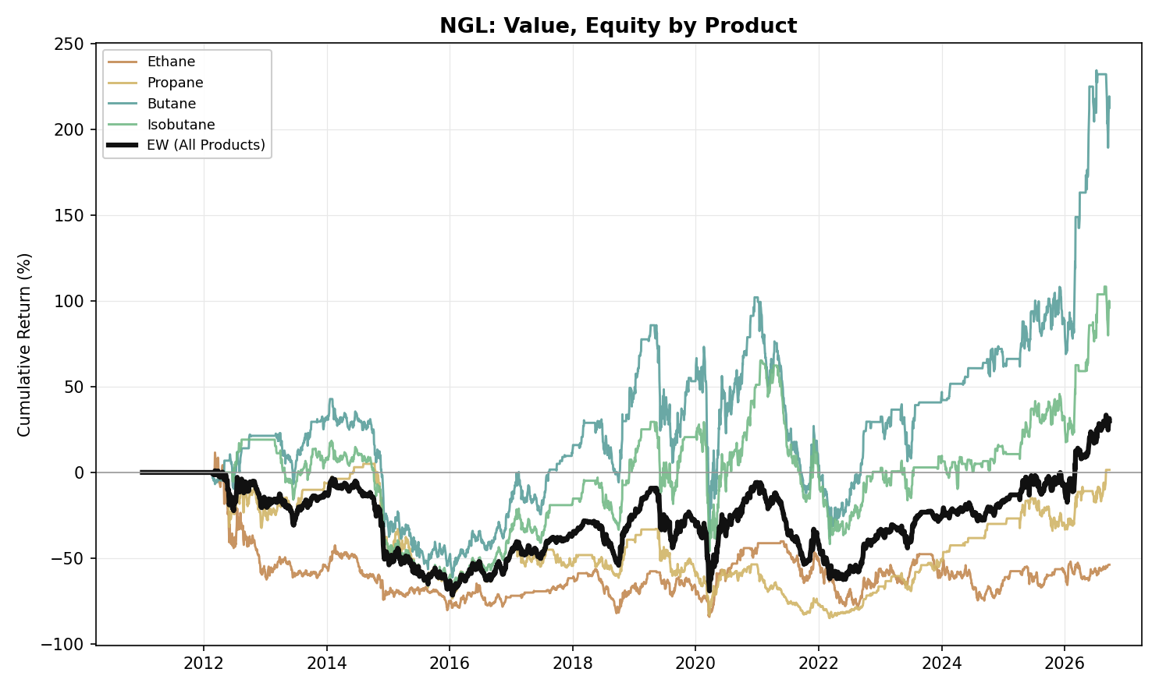
Figure A16. NGL, Value: Equity Curve by Product (2011-2026)

Agriculture
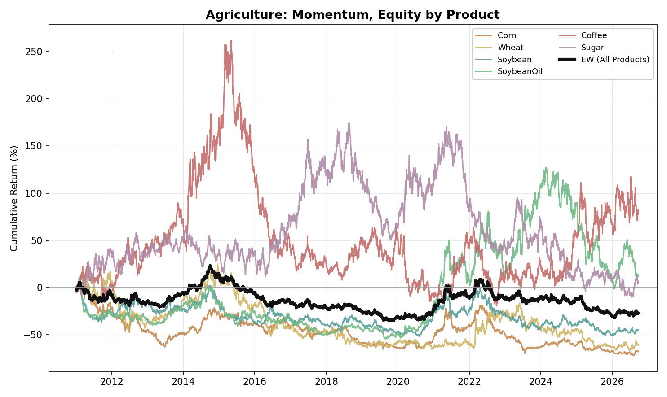
Figure A17. Agriculture, Momentum: Equity Curve by Product (2011-2026)
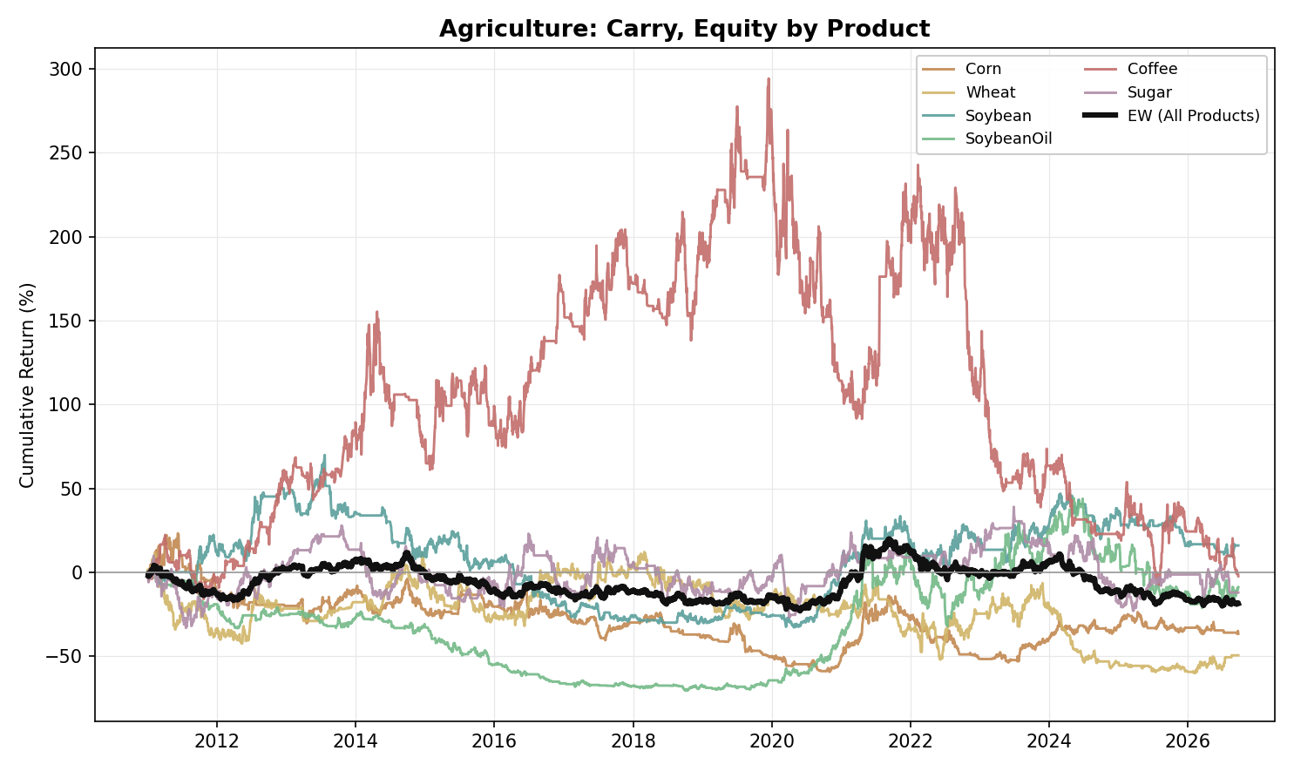
Figure A18. Agriculture, Carry: Equity Curve by Product (2011-2026)
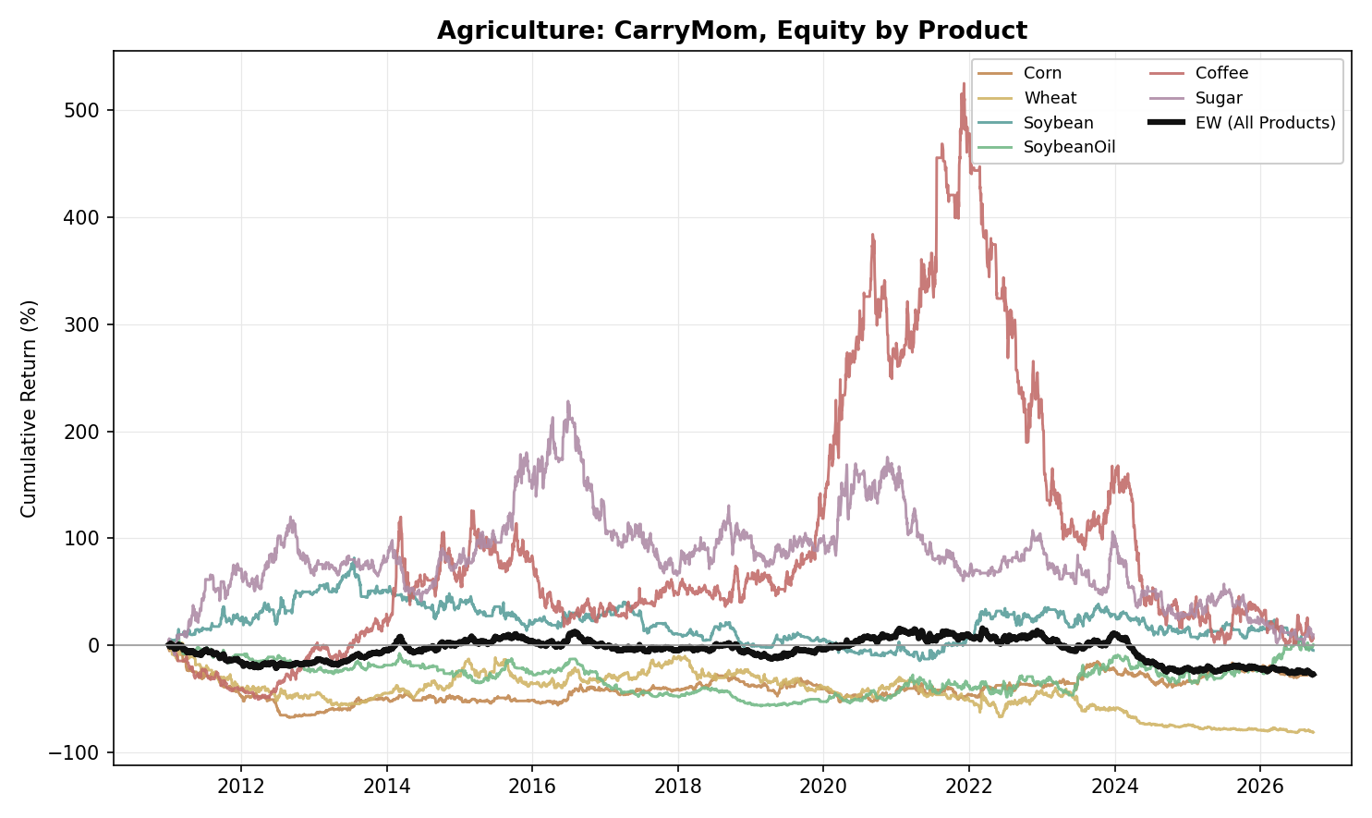
Figure A19. Agriculture, Carry-Momentum: Equity Curve by Product (2011-2026)
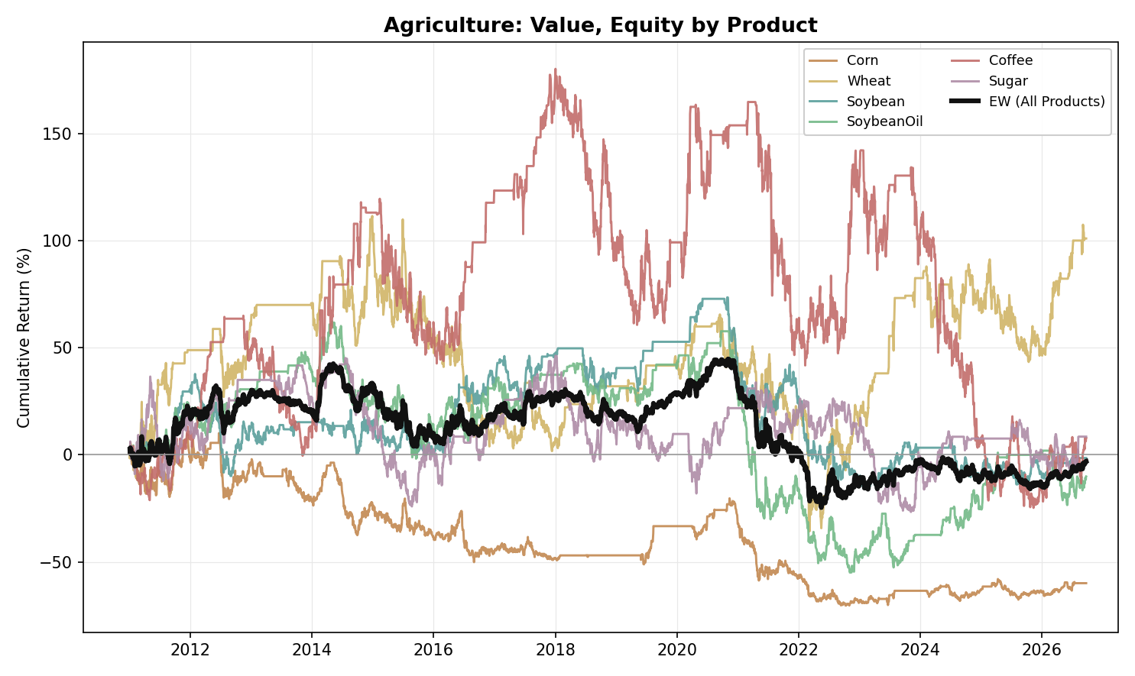
Figure A20. Agriculture, Value: Equity Curve by Product (2011-2026)

Cross-Pair Portfolios
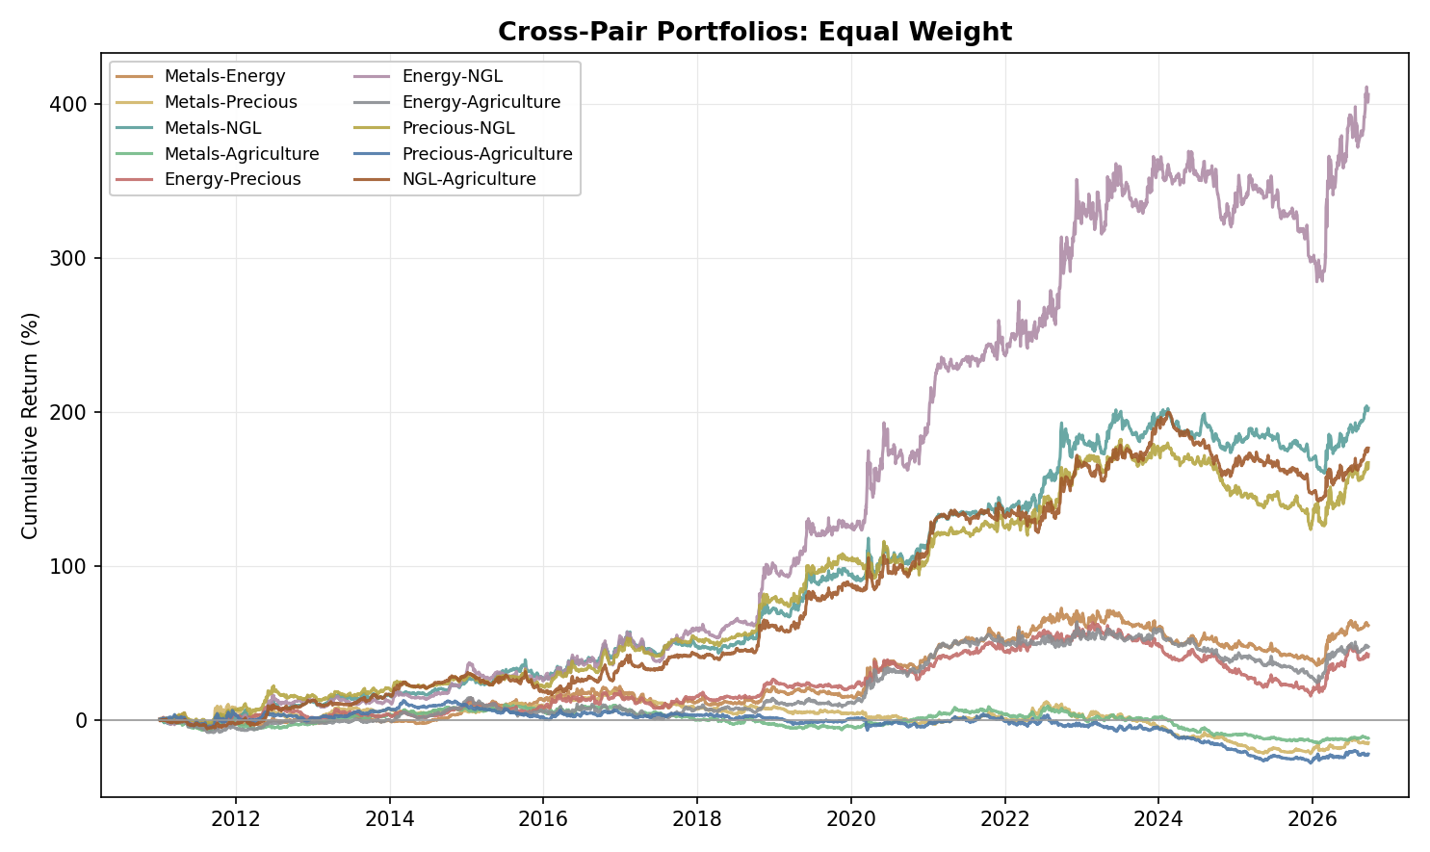
Figure A21. Cross-Pair Portfolios, Equal Weight: Equity Curve by Asset-Class Pair (2011-2026)
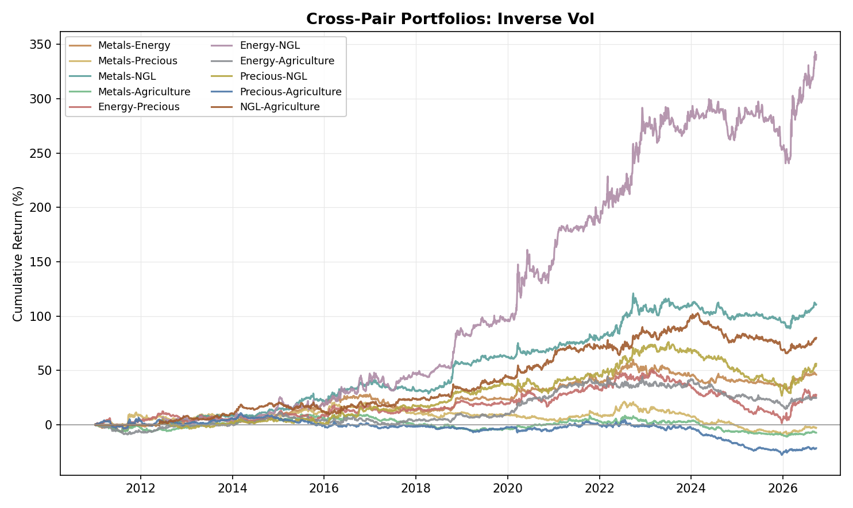
Figure A22. Cross-Pair Portfolios, Inverse Vol: Equity Curve by Asset-Class Pair (2011-2026)

